Research briefing

### @prospecteconom www.prospect.org.uk

#### 12 June 2025

## Spending Review 2025

### Contents

* Introduction
* Economic background and forecasts
* Overall spending plans for 2026-29
* Announcements of interest to key sectors
* Prospect’s response

### Introduction

Following the autumn “Spending Round” which set departmental budgets for the current fiscal year 2025-26, this Spending Review allocates current budgets for the following three years 2026-27, 2027-28, and 2028-29, and capital budgets for the four years 2026-27 to 2029-30.

It therefore has important consequences for civil servants and anyone working in the public sector, for industries in which public investment and regulation plays a role, and for workers and businesses throughout the economy.

It also represents a key moment for the Government to set out how it intends to advance its “missions” during the current Parliament.

This briefing aims to highlight key information and implications that may be of particular interest to members. It does not aim to cover all announcements or developments that might impact members given that these will be widely covered elsewhere.

### Economic and fiscal forecasts

There is not a new economic and fiscal forecast to accompany this Spending Review, as the OBR produced one in March (presented as part of the Chancellor’s “Spring Statement”) and will do so again alongside the Autumn Budget.

This means that the forecast produced in March remains the Government’s official planning assumption, and the “envelope” of total spending allocated by the Spending Review is the one set out in March.

### Overall spending plans for 2026-29

The Government’s Autumn Budget included key tax measures aimed at increasing revenues over the coming period, the largest of these being the increase in employers’ national insurance contributions, and reformed fiscal rules that allow additional borrowing for public investment as well as scope to use loans and guarantees to support private investment without it adding to public debt.

This enabled the Chancellor to pencil in significant increases in public spending over the parliament.

In March a deteriorating economic and fiscal forecast forced the Government to cut the amount of money earmarked for departmental current spending over the Spending Review period 2026-27 to 2028-20.

Nevertheless, its spending plans remain much more generous than those pencilled in by the last Government at the March 2024 budget.

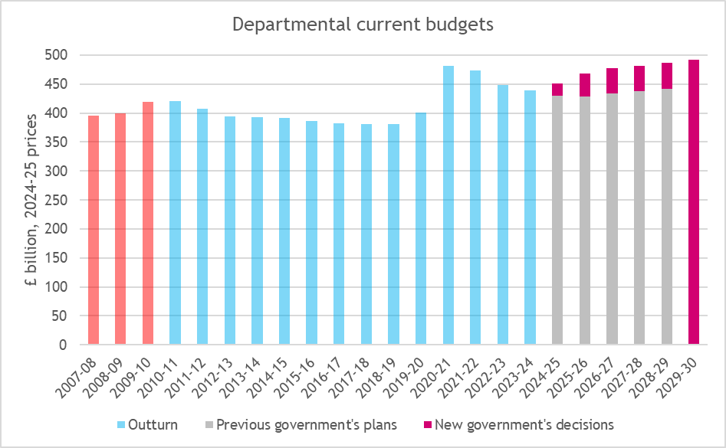

*Source: Prospect analysis of OBR data*

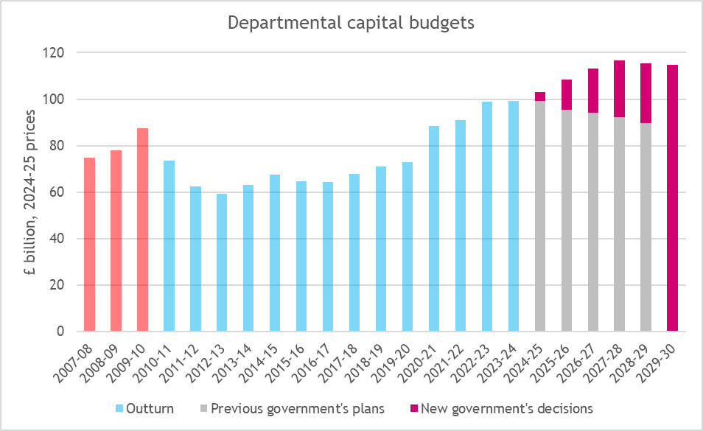

*Source: Prospect analysis of OBR data*

Much of the growth in current public spending has been allocated to the NHS and a few other priority areas, and a number of other areas of spending will face very tight and in some cases contracting real terms budgets in the years following 2025-26.

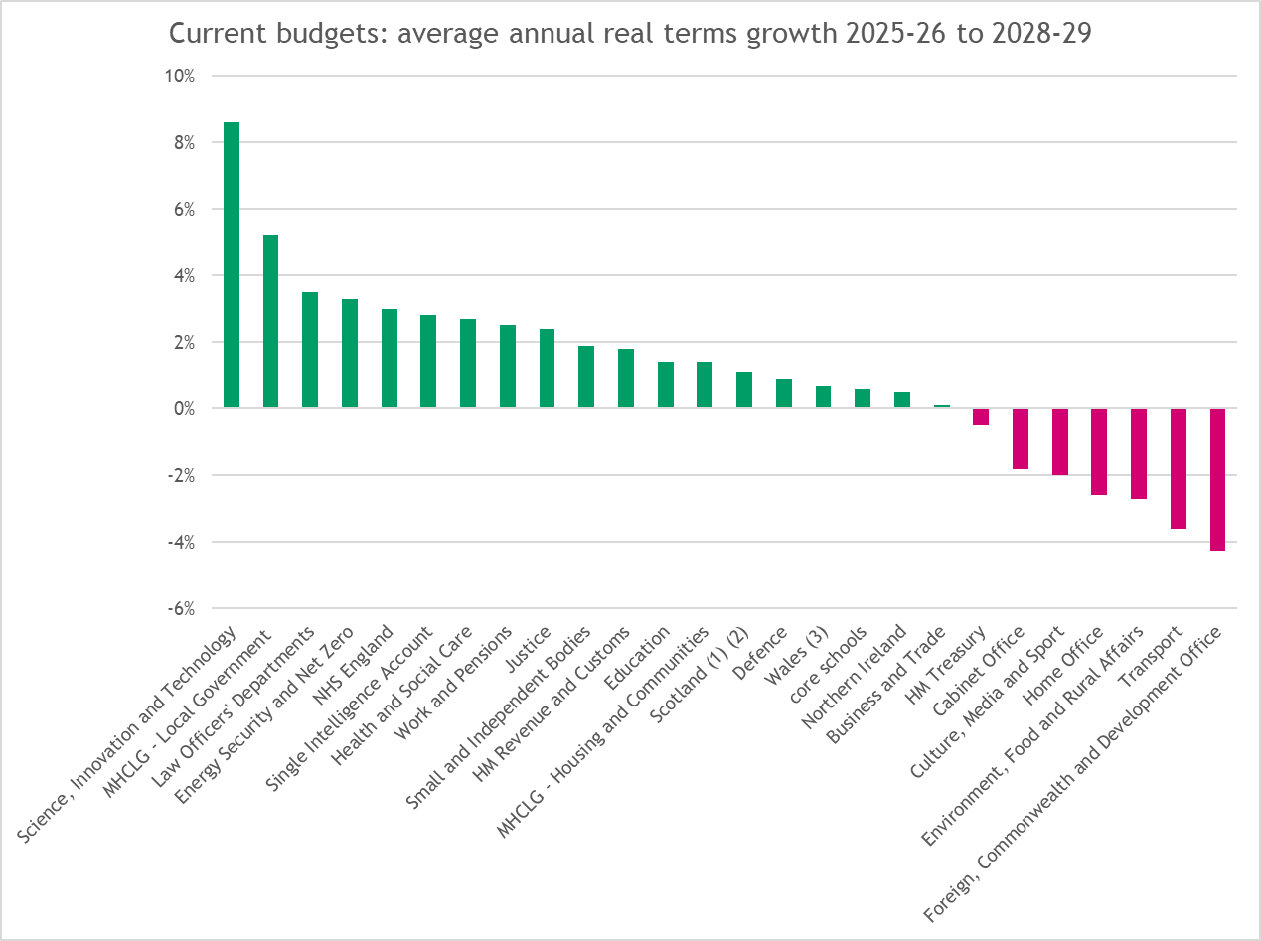

*Source: Prospect analysis of HMT data*

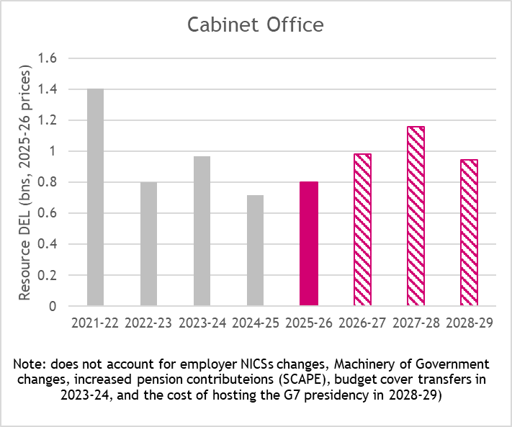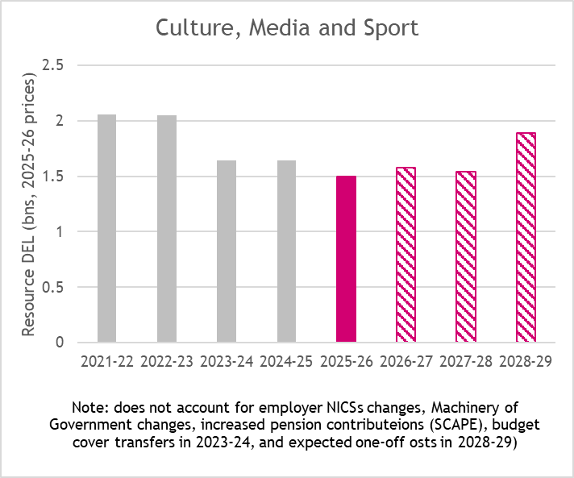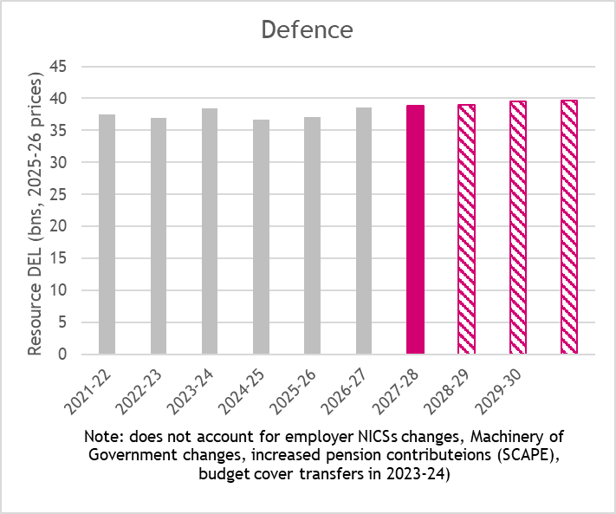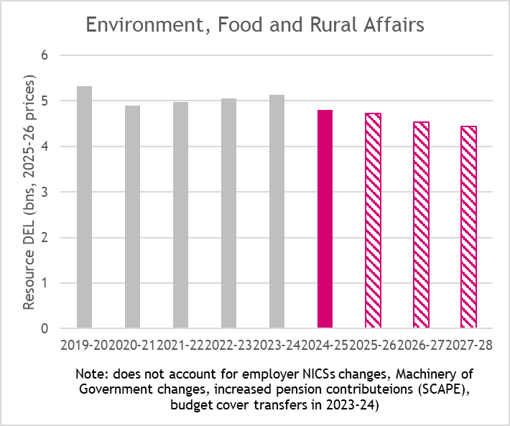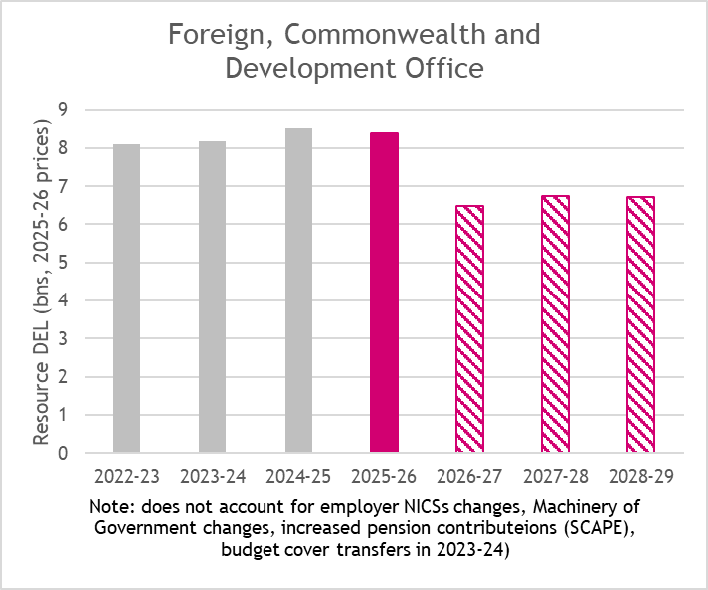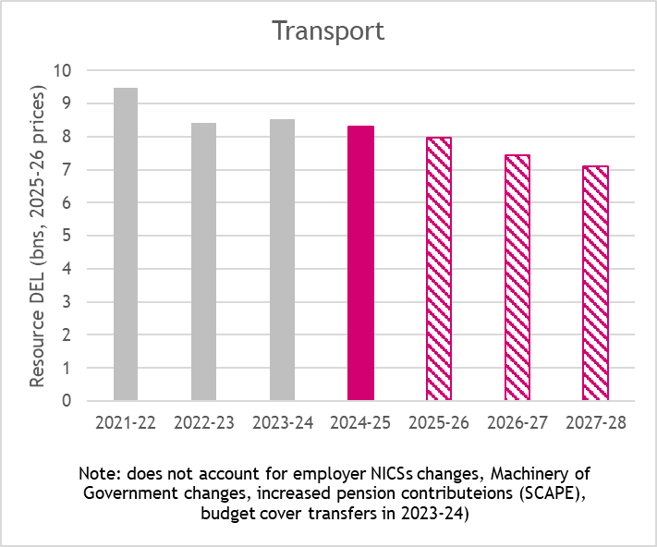

*Source: Prospect analysis of HMT and OBR data*

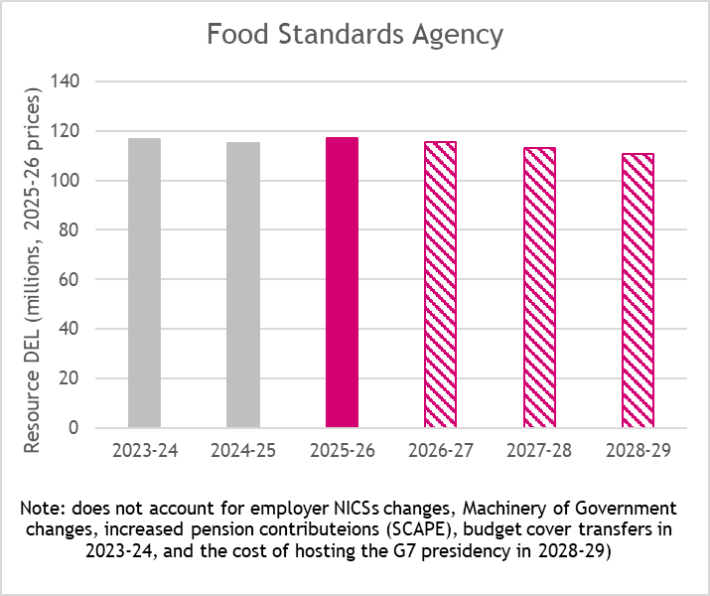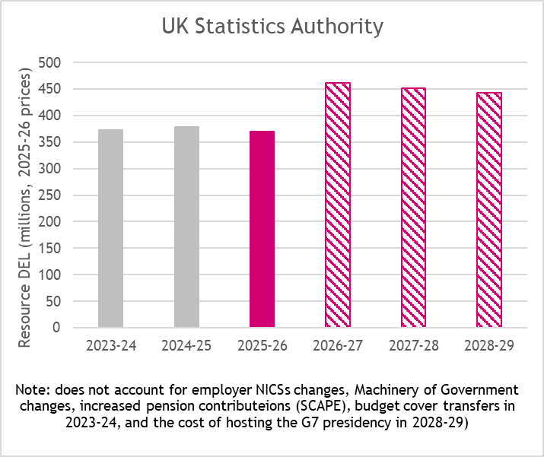

*Source: Prospect analysis of HMT and OBR data*

The largest increases in capital expenditure compared to the final year of the previous Government will be seen by defence, energy (including commitments to Sizewell C), science, innovation and technology, health, and transport (excluding HS2 which falls),

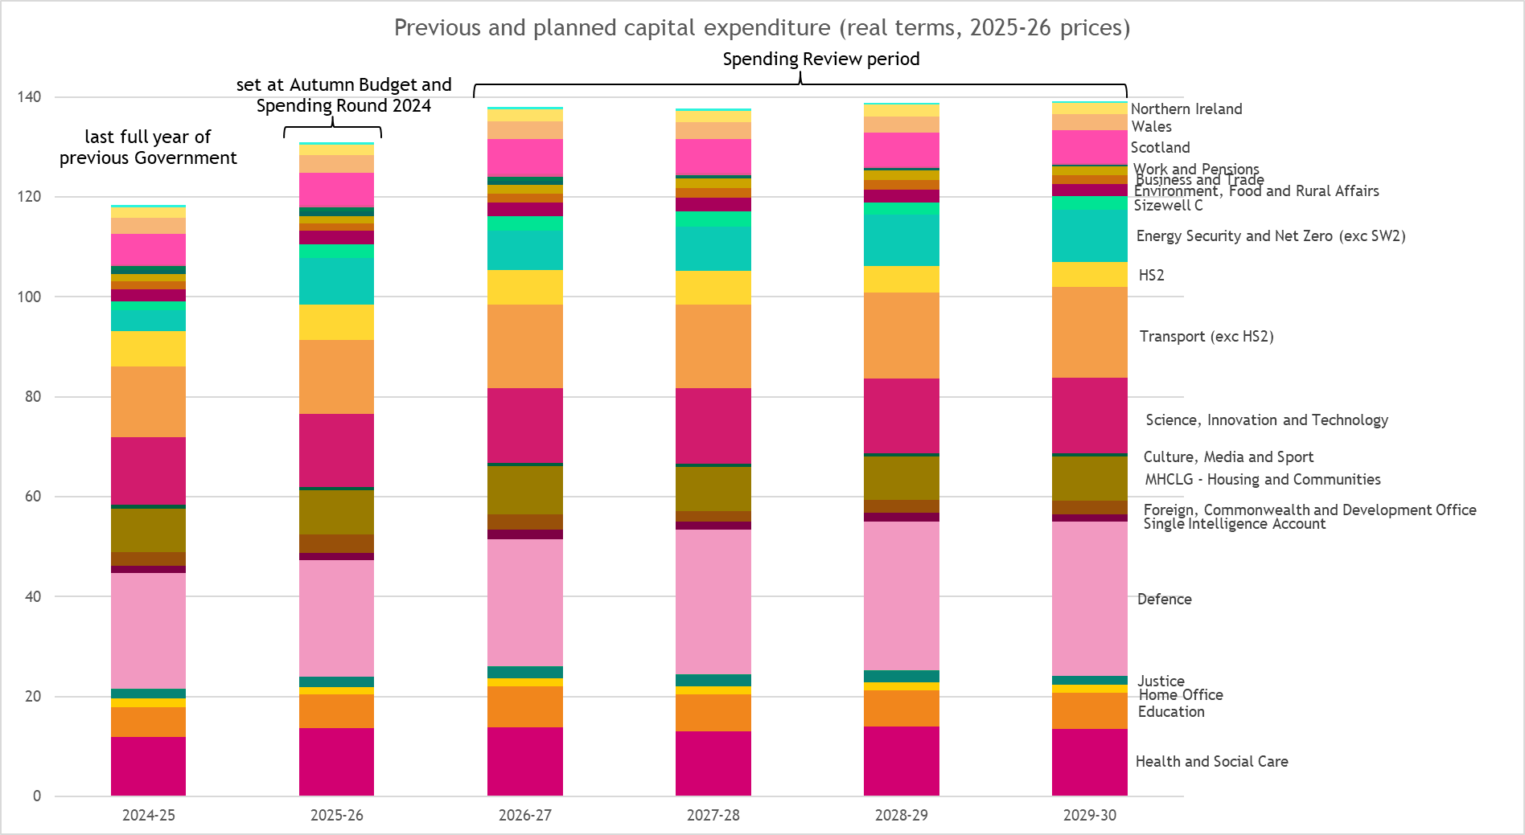

*Source: Prospect analysis of HMT and OBR data*

### Announcements of interest to key sectors

*Aviation*

The Spending Review extends the Advanced Fuels Fund to 2029-30. No detailed figures are provided but previous announcements indicated that since its launch the Fund has allocated over £135m in windows 1 and 2[1] and a further £63m in 2025.[2]

Ahead of the 2020 Spending Review the Sustainable Aviation Coalition called for £500m to be committed over three years.[3]

*Creative industries*

The Spending Review states that it is providing “a significant increase in funding for the creative industries as one of the government’s eight growth driving sectors”. This includes:

* “Transformative capital investment for culture, heritage, youth and sports infrastructure”
* “Funding for the UK’s world-leading culture and heritage sector, with billions over the SR period to fund celebrated institutions such as the National Museums and Galleries and organisations like Arts Council England”
* “funding across the SR period to develop new youth facilities and improve existing ones, as well as further funding to support local youth service provision”
* “Funding to deliver world-class major sporting events”

Against official inflation forecasts, however, the Department of Culture, Media and Sport sees a real terms cut in both current and capital spend once various adjustments such as NIC changes and one-off costs are taken into account.

According to Spending Review documentation, DCMS capital spending is set to fall an average 2.8% a year in real terms from 2025-26 to 2029-30.

The reduction in annual current spending, of the order of £100m in real terms, is on a similar scale to the Department’s entire “administration” spend, implying that “programme” spend via ALBs in areas such as arts and culture, heritage, libraries or sport may also be hit.

Concerns about the potential negative impact on the cultural sector were expressed by SOLT & UK Theatre, and the chair of the parliamentary Culture, Media and Sports Committee.[4]

*Defence*

The MOD’s budget to 2029-30 was already set out ahead of this Spending Review as part of the Spring Statement in March.

This confirmed the previously announced commitment to increase spending to 2.5% of GDP by 2027-28, funded by a commensurate reduction in the overseas aid budget. It also announced that an initial step towards this would be made by adding 2.2bn to defence spending in 2025-26.

*Source: Prospect analysis of HMT and OBR data*

Almost all of this increase in defence spending is allocated to capital, instead of current, budgets. Provisional analysis suggests that over the next five years the defence capital budget will grow by an average 7% a year in real terms while the current budget grows by just 1% a year in real terms.

This means the increase to 2.5% of GDP is likely to be of greater benefit to defence suppliers and their workforce than armed forces personnel or civilian staff of MoD and its agencies, with the exception of those whose work can be classified as R&D which means their employment can be funded from capital budgets.

The Institute for Fiscal Studies have questioned whether this has been determined by the Government’s fiscal rules and targets rather than an assessment of how best to upgrade the UK’s defence capabilities.[5]

Building on the recently published Strategic Defence Review, the Spending Review states that this investment will include:

* Nuclear: £15 billion over this Parliament for a sovereign warhead programme, supporting over 9,000 jobs in the UK;
* “Directed energy weapons: nearly £1 billion of new funding this Parliament to deliver the first European laser-directed energy weapon in service;”
* “Autonomous systems: over £4 billion in autonomous systems. This will include £2 billion of new investment this Parliament, including for land drone swarms;”
* “Munitions: £6 billion for munitions this Parliament, including £1.5 billion for an ‘always on’ pipeline and at least six new energetics and munitions factories in the UK, generating over 1,000 jobs;”
* “Infrastructure: at least £7 billion in this Parliament for a once in a generation renewal of military accommodation, including over £1.5 billion new investment for rapid work to fix forces family housing.”

The Spending Review also promises that “the upcoming **Defence Industrial Strategy** will set out how the government will maximise the untapped growth potential of defence, as one of the eight priority sectors under the government’s modern Industrial Strategy, including capitalising on synergies between defence and other priority sectors such as advanced manufacturing and digital and technology”.

As set out above, the current budget allocation for the MoD itself is extremely tight, growing just 0.7% a year in real terms between 2025-26 and 2028-29. This is likely to be reflected in pressure on pay, terms and conditions, and headcount over the coming period.

Documents accompanying the Spending Review reveal that a “**Defence Reform and Efficiency Plan**” will be published in the autumn setting out how “will set out how the restructured department will reduce duplication, reform the department’s Civil Service workforce to increase productivity, realise greater efficiencies in the department’s estate, and improve procurement processes”.[6]

*Energy*

The Spending Review confirms “significant investment in the nuclear sector” including

* “£14.2 billion for Sizewell C over the SR period”
* “over £2.5 billion to enable one of Europe’s first Small Modular Reactor programmes, with Rolls-Royce SMR selected as preferred bidder to partner with Great British Energy – Nuclear, subject to all relevant approvals”
* “over £2.5 billion for nuclear fusion, including support for the UK’s world-leading programme to design and build a prototype energy plant in Nottinghamshire”

In addition “Great British Energy - Nuclear has been tasked with assessing proposals within a new framework, to be published shortly, with the National Wealth Fund exploring potential investment opportunities and the Department for Energy Security and Net Zero exploring revenue support for viable projects”.

The Spending Review provides £13.9 billion in capital budgets to the Nuclear Decommissioning Authority, which (assuming this covers the four year period covered by other capital settlements – though this is not entirely clear) equates to around £3.5bn a year cash. This on its own would represent a modest uplift on the NDA’s total funding of £3.305bn in 2025-26,[7] though is some way below total funding of previous years.[8] It is not immediately clear from Spending Review documents to what extent this capital settlement will be supplemented by Resource funding.

Confirmation of Sizewell C, along with wider investment in nuclear energy, was a prominent element in Prospect’s submission to the Spending Review and subsequent engagement with the Treasury and Government.

Other announcements include

* “confirming up to £80 million over the SR period for port investment to support floating offshore wind deployment in Port Talbot, subject to final due diligence”
* “Allocating £9.4 billion to Carbon Capture, Usage and Storage (CCUS) over the SR period. The government’s support will attract private investment and support thousands of jobs across the supply chain”

The document confirms that the **Clean Energy Industries sector plan** will be published as part of the Industrial Strategy later in June.

*Environment and Food*

As indicated above, the Defra group faces significant real terms cuts to current budgets over the Spending Review period.

Specific announcements in the documentation include:

* increasing support for nature-friendly farming through Environmental Land Management schemes from £800 million in 2023-24 to £2 billion by 2028-29, sustained by rapidly winding down subsidy payments that do not provide a return on investment
* £4.2 billion TDEL over three years (2026-27 to 2028-29) to build and maintain flood defences

Supplementary documentation states that Defra will devlier efficiency gains of £144m per year by 2028-29 through:

* “improving workforce productivity in the core department” including
  + estate rationalisation
  + “streamlining back-office functions”
  + decreasing the number of digital devices issued to staff
  + “reducing reliance on digital contractors”
  + “headcount reductions. The department has already reduced headcount by around 8% since July 2024 and will reduce by a further 5% during 2025-26.”
* “modernising services delivered by ALBs” – including
  + “automating document checks”
  + “simplifying policy delivery”
  + reorganising grants administration
  + “reforming how Defra and its ALBs ensure compliance with environmental regulations – covering inspections, enforcement, and monitoring”
  + “Transforming registration, licensing, and approvals services using AI and automation”
* “improving efficiency in ALBs” – giving the example of the Environment Agency’s planned introduction of remote monitoring and flood warning automation

*Heritage*

The Spending Review highlights DCMS investment to “safeguard and modernise much-loved cultural and heritage institutions in towns and cities”, and funding for “celebrated institutions such as the National Museums and Galleries and organisations like Arts Council England”.

Accompanying figures however show that DCMS current funding will fall by an average 1.2% a year in real terms between 2025-26 and 2028-29, and capital funding will fall by an average 2.8% between 2025-26 and 2029-30.

The reduction in annual current spending, of the order of £100m in real terms, is on a similar scale to the Department’s entire “administration” spend, implying that “programme” spend via ALBs in areas such as arts and culture, heritage, libraries or sport may also be hit.

Supplementary documents state that “DCMS and its public bodies will deliver efficiency gains of £52m per year by 2028-29” through reforms to

* “workforce – consolidating and restructuring staffing, reducing turnover levels, reducing reliance on contingent or contracted labour and reviewing staff grading, pay scales and locations”
* “finance and grants – tighter budget management and staff productivity gains from automation and more investment in fraud prevention”
* “digital – modernising applications, reducing duplicate digital solutions and devices, updating IT systems to enable more automation to reduce staff time on administrative tasks”
* “communications and marketing – designing user-focused services, consolidating websites, restructuring marketing teams and reducing reliance on external design contractors”
* “estates – merging back-office and storage functions into single sites, reducing office space across regional ALB sites, and leasing spare storage space.”

It further states that “All of DCMS’s public bodies are encouraged 26 to maintain a productive and efficient workforce through a combination of reduction in full-time equivalent staff, staff re-grading and time savings.”

Responding to the Review the Museums Association said

*“We await the details in terms of the settlements for national museum and ACE budgets but are concerned that at a time when museums are delivering for communities and against government agendas they face the prospect of more cuts and face financial uncertainty.”[9]*

*IT and telecoms*

The SR confirms £1.9 billion over the SR period for Building Digital UK (BDUK) “to deliver the next phase in the transformation of the country’s digital infrastructure”. This includes

* “Connecting more homes and businesses to gigabit-capable broadband to reach 99% of UK premises by 2032. BDUK will focus delivery in this SR period on achieving greater coverage in Scotland and Wales, and refresh delivery plans ahead of the Spending Review 2027”
* “Working with industry to deliver the Shared Rural Network so the most remote areas have 4G coverage”

Although not highlighted by the Government the promise to deliver gigabit-capable broadband to 99% of UK premises by 2032 appears to reflect an delay to the previous target deadline of 2030.[10]

*Public services*

The Spending Review increases targets for reductions in “administration” spending to 11% in real terms by 2028-29, and 16% in real terms by 2029-30. This change in the overall target is largely the result of a few bodies (FCDO, HMRC and “small and independent bodies”) being given a target for deeper cuts in admin spend than the 10% and 15% applied to every other department. (As the IFS have highlighted, this targets applied almost uniformly to almost all departments means that those with growing budgets will a sharper fall in the proportion of their spending allowed for “administration” as a result.[11])

As highlighted in previous briefings, Prospect research has established that in Treasury terms, “administrative” expenditure covers a broad range of functions and activities including policy advice and “technical or scientific support” as well as HR, communications, procurement and project management.[12] According to the Treasury’s own documentation, administrative budgets “help to drive economy and efficiency in the running of government”.[13]

The Spending Review also states that the government will seek

*“to build capability across the civil service and ensure it can attract, develop and retain a high-performing workforce. This will include specialist digital talent, where the government has committed to one in ten civil servants working in digital roles by 2030. The government will also publish the first ever* ***civil service strategic workforce plan later this year****, and monitor progress against this plan to ensure that departments are successful in delivering an efficient and cost-effective workforce.”* [emphasis added]

Other initiatives highlighted include:

* “streamlining recruitment and expanding the use of secondments for critical priorities”
* “Minimum performance standards for senior civil servants”
* “£50 million from the Transformation Fund to increase workforce productivity, including to transform the model of civil service learning and development, and reduce dependency on costly external training provision”
* Continued relocation of roles outside London – “by 2030, will reduce the number of civil servants based in London by 12,000 and have 50% of UK-based senior civil servants in regional offices across the UK”
* Investment of £244 million to complete the development of new government hubs including Darlington, Manchester First Street and York
* 11 central London offices will be closed, including 102 Petty France and 39 Victoria Street

On **ALB**’s the Spending Review states:

*“The government has demonstrated that it is willing to take bold decisions by announcing that NHS England will be merged into the Department of Health and Social Care (DHSC). The government is also moving quickly to merge the Valuation Office Agency into HMRC by the end of 2025-26.*

*“The government has commenced a review of all ALBs that will identify further opportunities for closures, mergers and consolidations. Further details on the outcomes of this review will be announced in due course.*

*“The government is committed to streamlining the operations of ALBs through targeted efficiency measures through the OVfM technical efficiency process.”*

More detail is set out on how the 3.25bn **Transformation Fund** announced at the Spring Statement will be allocated. This includes

* £70m for civil service employee exit schemes in 2026-27, following 73m allocated for 2025-26
* £25m for “Civil Service transformation” in 2026-27 and 2027-28
* £323m to be spent over three years on “support for the Digital Centre for Government and cross-cutting digital priorities”

On **public sector pay** the Spending Review reiterates previously used language:

*“Pay awards will need to be funded within the departmental settlements set out below … if the PRBs recommend pay increases above the level departments have budgeted for, departments will need to carefully consider the justification for these awards and determine whether these additional costs can be borne either through offsetting savings or through further productivity gains.”*

The Resolution Foundation commented that while over the long run the Government “has little choice but to pay enough to attract and retain staff who have the option to work in the private sector”, on the basis of the latest labour market data and forecasts “it seems unlikely that the Government will need to repeat the relatively large pay increases of the past two years”.[14]

*Science*

The Spending Review states that R&D has been “prioritised to complement investments in infrastructure and contribute to the success of “growth-driving sectors”.

Total R&D funding will reach £22.6bn in 2029-30, a real terms increase against the latest official inflation forecasts though a fairly modest one compared to the increases begun in 2016 and still short of the £22bn that was at one stage promised by the last Conservative Government but subsequently postponed till after the last election.

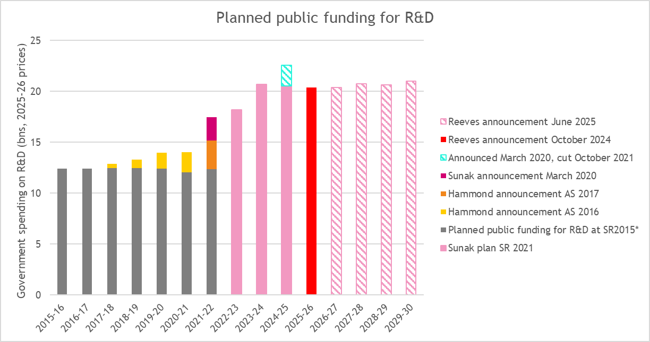

The Spending Review document states that this funding will include:

* £500 million for the new R&D Missions Accelerator Programme, which will “leverage a further £1.5 billion of private investment into innovation challenges that support the government’s missions”
* “New opportunities for top talent, including fellowship schemes which will attract the brightest scientists to the UK. The government is exploring expanding eligibility of the High Potential Individual visa, looking to double the number of qualifying institutions, whilst maintaining the focus of the route on individuals that will have the most benefit to the UK workforce, and ensuring that any necessary safeguards are in place; improving access to the Global Talent visa, and reviewing the Innovator Founder visa to support entrepreneurs”
* “At least £1 billion over the SR to scale up the Advanced Research and Invention Agency (ARIA), the UK’s high-risk, high-reward research agency”
* “Up to” £750 million for a new supercomputer at Edinburgh University

Responding to the announcement the Campaign for Science and Engineering said “The Chancellor’s speech today has brought welcome confirmation of the announcements made at the weekend that the UK R&D budget is being protected in tough fiscal circumstances.”[15]

*Transport*

Transport related announcements include £24 billion of capital funding between 2026-27 and 2029-30 for National Highways and local authorities to invest in “significantly improving the long-term condition of England’s road network”.

Alongside this, however, the Department for Transport receives one of the tightest current budget settlements of the review, and is expected to deliver “efficiency gains” of £663m per year by 2028-29, including:

* A “workforce strategy” to “help it become a smaller department, which is more skilled, agile, and productive”
* Reform of executive agencies including digitisation and workforce restructuring at DVSA, DVLA and VCA

Accompanying documents also highlight the fact that “Efficiencies” are “embedded” in National Highway’s five-year financial settlement for each Road Investment Strategy (RIS) and monitored by the ORR.

### Prospect’s response

**Responding to the Spending Review, Mike Clancy, General Secretary of Prospect, said:**

*“This increased capital investment in areas like energy, defence, and housing is an important step change, along with maintaining R&D spending, in supporting the areas of the economy that can fuel the growth of tomorrow. The government must move quickly to publish and implement an ambitious industrial strategy and make sure that the skills system gets the urgent attention it needs to make sure workers will see the benefits.*

*“While this investment is welcome, the government’s real terms cuts to day-to-day spending in some unprotected departments are worrying and could have a real impact on the government’s ability to deliver on its missions.*

*“The government will need to articulate much better what it wants the civil service to stop doing, given many essential government agencies are already facing recruitment and retention crises, particularly for specialist digital, scientific and technical staff.*

*“Only by investing in the skills it needs will it be able to achieve its objectives and undo the damage of the last 15 years.”[16]*

**This briefing will be updated as new information and analysis comes to light. Please direct any suggestions, corrections or queries to martin.mcivor@prospect.org.uk**

1. https://www.gov.uk/government/publications/advanced-fuels-fund-competition-winners/advanced-fuels-fund-aff-competition-winners
2. https://www.gov.uk/government/news/boost-for-british-green-aviation-fuel-production-to-support-jobs-and-lift-off-emerging-industry
3. https://www.sustainableaviation.co.uk/wp-content/uploads/2020/10/Sustainable-Aviation-CSR-Submission-FINAL-240920.pdf
4. <https://www.artsprofessional.co.uk/news/spending-review-government-pledges-additional-400m-for-dcms-in-2028>; https://www.theartnewspaper.com/2025/06/12/uk-department-of-culture-faces-cuts-following-government-spending-review
5. <https://ifs.org.uk/sites/default/files/2025-03/Public_service_spending_small_changes_big_challenges_BB.pdf>
6. https://assets.publishing.service.gov.uk/media/68492799d0ca5d7801e4e709/Efficiency_delivery_plans_-_supplementary_document_-_FINAL.pdf
7. https://www.gov.uk/government/consultations/nuclear-decommissioning-authority-draft-business-plan-2025-to-2028-for-consultation/nuclear-decommissioning-authority-draft-business-plan-2025-to-2028-for-consultation
8. https://assets.publishing.service.gov.uk/media/6703df05080bdf716392ef1c/ARAC_2023-24_final_for_web.pdf
9. https://www.museumsassociation.org/museums-journal/news/2025/06/spending-review-reveals-cut-to-dcms-budget/
10. <https://questions-statements.parliament.uk/written-questions/detail/2024-10-28/11467>; https://www.ispreview.co.uk/index.php/2025/06/govs-2025-spending-review-delays-uk-gigabit-broadband-target-to-2032.html
11. https://ifs.org.uk/sites/default/files/2025-06/Spending_Review_analysis_impacts_for_public_services_MW.pdf
12. https://assets.publishing.service.gov.uk/media/65f0a26d9812270011f61417/CBG_2024-25.pdf
13. https://assets.publishing.service.gov.uk/media/66a8dd93ab418ab055592fb9/E03149684_PESA_2024_Web_Accessible.pdf
14. https://www.resolutionfoundation.org/app/uploads/2025/06/Spending-Review-2025.pdf
15. https://www.sciencecampaign.org.uk/press/detail/response-to-spending-review-2025/
16. https://prospect.org.uk/news/the-government-must-move-quickly-to-publish-and-implement-an-ambitious-industrial-strategy-and-invest-in-skills